1. INTRODUCTION
1.1. Project Overview
Advancing Nutrition Science through GeminiAI is an AI-powered web-based application designed to provide users with comprehensive nutritional information about food items. The system leverages Google Generative AI (Gemini) to deliver instant and detailed insights into macronutrients such as proteins, fats, and carbohydrates, as well as micronutrients including vitamins and minerals, along with calorie estimation.
The application is developed using Streamlit for the user interface and integrates the Gemini 2.5 Flash model for real-time intelligent nutrition analysis. It assists users in understan2ding food composition, planning healthier diets, and receiving personalized nutrition guidance.
This project demonstrates the practical use of generative AI in healthcare and nutrition by offering a fast, interactive, and user-friendly platform for dietary awareness and meal planning.
1.2. Objectives
The main objectives of this project are:
- To develop an AI-powered web application for nutritional analysis
- To provide detailed macronutrient and micronutrient information about foods
- To generate personalized weekly meal plans based on user preferences
- To provide virtual nutrition coaching using AI
- To help users make informed dietary decisions
- To create a simple and user-friendly interface using Streamlit

2. Project Initialization and Planning Phase
2.1. Defining Problem Statement
Many individuals struggle to understand the nutritional value of their daily food intake and often fail to maintain balanced diets. Manual diet planning and consulting nutrition experts can be expensive and time-consuming. Moreover, most existing tools provide generic and non-personalized nutrition advice.
This project solves the problem by providing an AI-powered system that delivers real-time personalized nutrition insights, meal planning, and virtual coaching using Gemini AI.

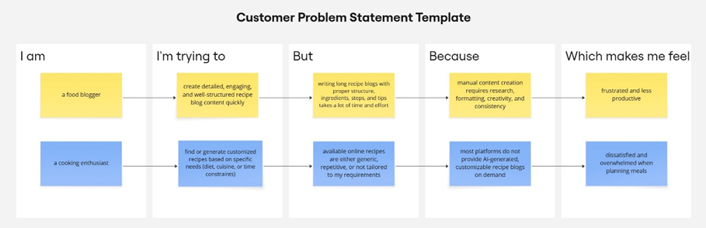

Problem  Statement  (PS) | I am | I’m trying to | But | Because | Which makes me feel
PS-1 | A food blogger | Create detailed, and high-quality recipe blog content in less time | Writing long and recipe blogs manually is time-consuming | It requires research, creativity, formatting, and consistency | Frustrated and less productive
PS-2 | A cooking enthusiast | Generate customized recipes | Existing recipes available online are generic and not customizable | Most platforms do not offer AI-driven recipe blog generation | Dissatisfied and overwhelmed while planning meals

2.2. Project Proposal (Proposed Solution)
Project Overview
Objective | The main objective of this project is to develop an AI-powered web application that generates customized and high-quality recipe blogs based on user inputs.
Scope | The scope of the project includes building a Streamlit-based web interface where users can enter a recipe topic and desired word count. The system generates a complete recipe blog using an AI model and displays it to the user.
Problem Statement
Description | Many food bloggers and users find it difficult to create detailed and well-structured recipe blogs within a short time. Manual content creation requires creativity, research, and proper formatting, making it time-consuming.
Impact | Solving this problem helps users save time and effort while creating customized recipe blogs
Proposed Solution
Approach | The proposed solution uses a Streamlit web application integrated with the Gemini Flash Lite model. Users provide a recipe topic and word count through the UI. The AI model processes the input and generates a complete recipe blog.
Key Features | - User-friendly Streamlit interface  - AI-powered nutritional analysis  - Image-based food nutrition detection  - Virtual AI nutrition coach

Resource Requirements
Resource Type | Description | Specification/Allocation
Hardware
Computing Resources | CPU for application execution | Standard system CPU
Memory | RAM required to run application | 8 GB
Storage | Disk space for application files | 50 GB SSD
Software
Frameworks | Python web framework | Streamlit
Libraries | AI and utility libraries | google-generativeai
Development Environment | IDE and version control | VS Code, Git
Data
Data | User input text | Food Items names entered by user

2.3. Initial Project Planning
Product Backlog, Sprint Schedule, and Estimation
The following table represents the product backlog and sprint-wise planning for the Nutrition Science project.
Sprint | Functional Requirement (Epic) | User Story Number | User Story / Task | Story Points | Priority | Team Members | Sprint Start Date | Sprint End Date
Sprint 1 | User Interface Setup | USN-1 | As a user, I can access a Streamlit-based interface to enter a recipe topic and word count. | 2 | High | All Team Members | 28 January 2026 | 31 January 2026
Sprint 1 | Input Validation | USN-2 | As a user, I want the application to validate my inputs before generating the recipe. | 1 | High | All Team Members | 28 January 2026 | 31 January 2026
Sprint 2 | AI Model Integration | USN-3 | As a user, I want the system to generate a recipe blog using the Gemini Flash Lite model. | 3 | High | All Team Members | 02 February 2026 | 09 February 2026
Sprint 2 | Joke Generation | USN-4 | As a user, I want to see a programming joke while the recipe is being generated. | 1 | Medium | All Team Members | 02 February 2026 | 09 February 2026
Sprint 3 | Output Display | USN-5 | As a user, I want to view the generated recipe blog clearly on the screen. | 2 | High | All Team Members | 12 February 2026 | 18 February 2026
Sprint 3 | Deployment | USN-6 | As a user, I want the application to be deployed and accessible through the internet. | 2 | Medium | All Team Members | 12 February 2026 | 18 February 2026

3. Data Collection and Preprocessing Phase
3.1. Data Collection plan and Raw Data Sources Identified
3.1.1. Data Collection Plan
Section | Description
Project Overview | The application collects data dynamically from users through the Streamlit interface based on user input. The project dynamically processes user-provided text input to generate content.
Data Collection Plan | The data for this project is collected directly from users at runtime through a Streamlit-based web interface. Users provide:  - Dietary restrictions  - Health conditions
Raw Data Sources Identified | Since this project uses real-time user input and a pre-trained AI model, no external datasets (CSV, images, or files) are collected or stored.

3.1.2. Raw Data Sources Template
Source Name | Description | Location/ URL | Format | Size | Access Permissions
User Input Data | Text entered by users (recipe topic & word count) | Streamlit Web Interface | Text | Small | Public  (user-provided)
AI Model Output | Generated recipe blog content | Gemini Flash Lite API | Text | Variable | Restricted  (API-based)
3.2. Data Quality Report
Data Quality Report
The Data Quality Report summarizes potential data quality issues related to user-provided input in this application. Since the project does not rely on an external dataset, data quality focuses on ensuring valid, clean, and meaningful text input before processing by the AI model.
Data Source | Data Quality Issue | Severity | Resolution Plan
User Input (Text) | Empty or missing recipe topic | High | Input validation is applied to ensure the topic field is not empty before submission.
User Input (Text) | Invalid or very low word count | Moderate | Word count is validated to ensure it falls within an acceptable range.
User Input (Text) | Special characters or extra spaces | Low | Input text is cleaned by trimming unnecessary spaces before processing.
User Input (Text) | Ambiguous or unclear prompts | Low | Clear prompt formatting is applied before sending input to the AI model.

3.3. Data Preprocessing
In this Advancing nutrition project, data preprocessing focuses on user-provided textual input rather than images. Since the application uses a pre-trained generative AI model, no traditional dataset collection or image preprocessing is required.
Section | Description
Data Overview | The data used in this project consists of user-entered text inputs such as recipe topic and desired word count. No external dataset is used.
Text Cleaning | User input is cleaned by removing unnecessary spaces and validating empty or invalid entries.
Input Validation | Ensures the recipe topic is not empty and the word count is within an acceptable range.
Token Handling | The input text is passed to the Gemini Flash Lite model, which internally handles tokenization and text processing.
Prompt Formatting | The user input is formatted into a structured prompt before being sent to the AI model for recipe generation.
Error Handling | Handles invalid inputs or API-related issues gracefully by displaying appropriate error messages.
Data Preprocessing Areas
Loading Data | User inputs are collected directly through Streamlit text input fields.
Input Validation | Code ensures valid recipe topic and word count before processing.
Prompt Creation | Code formats the validated input into a prompt for the Gemini Flash Lite model.
Model Invocation | The formatted prompt is sent to the AI model for recipe blog generation.
Output Handling | The generated recipe text is received and displayed on the Streamlit interface.

4. Model Development Phase
4.1. Model Selection Report
In this project, the focus is on selecting a pre-trained generative language model suitable for real-time recipe blog generation. Unlike traditional deep learning projects that require training CNNs or RNNs, this application leverages an existing large language model (LLM) to generate high-quality text content. The model is selected based on performance, response time, ease of integration, and suitability for text-based content generation.
Model | Description
Gemini Flash Lite (models/gemini-flash-latest) | A lightweight pre-trained generative language model designed for fast and efficient text generation. It supports real-time content creation with good coherence, relevance, and low latency, making it ideal for recipe blog generation.

4.2. Initial Model Training Code, Model Validation and Evaluation Report
In this project, no custom model training is performed. Instead, a pre-trained generative AI model is integrated and used for recipe blog generation. The focus of this phase is on model selection, configuration, prompt design, and output evaluation, rather than training from scratch.
Initial Model Training Code:
Model Selection and Initialization
The Gemini Flash Lite (models/gemini-flash-latest) model is selected due to its lightweight architecture, faster response time, and suitability for real-time text generation tasks.
The model is initialized using the Google Generative AI API. Configuration parameters such as temperature, top-p, top-k, and maximum output tokens are defined to control creativity, response quality, and output length.

Model Validation and Evaluation Report:
Model | Summary | Training and Validation Performance Metrics
Gemini Flash Lite | Pre-trained generative language model optimized for fast text generation | Relevance of generated content, adherence to word count, coherence, clarity, and response time

5. Model Optimization and Tuning Phase
5.1. Tuning Documentation

The primary goal of the Model Optimization and Tuning phase is to enhance the accuracy, clarity, and usefulness of the responses generated by the Gemini AI model. Since the project uses a pre-trained generative AI model rather than training a custom neural network, optimization is achieved through prompt engineering, parameter tuning, and response formatting.
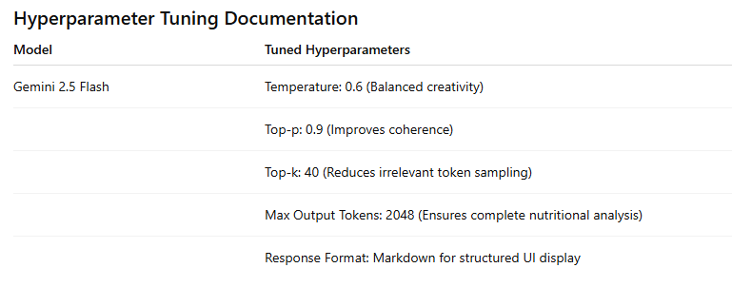
5.2. Final Model Selection Justification
Final Model | Reasoning
Gemini Flash Lite (models/gemini-flash-latest) | Selected due to its fast response time, efficient resource usage, high-quality text generation, and seamless integration with Streamlit for real-time recipe suggestions.

6. RESULTS
6.1. Output Screenshots
The complete execution of Advancing Nutrition Science through GeminiAI application is represented step by step in the following screenshots.
Step 1: To run the Streamlit Application we have to use the command streamlit run app.py in the terminal in path where the app.py file is located.
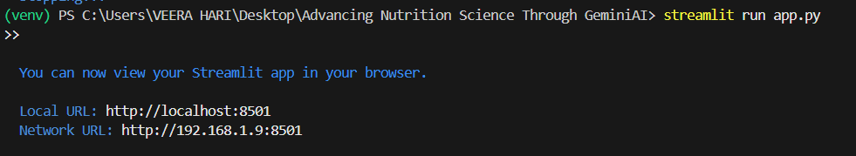

Step 2: After running the command in terminal, the code will get executed and the webpage will open directly. Another way to open webpage is that a localhost link will get generated in the terminal, we can access the webpage using that link.
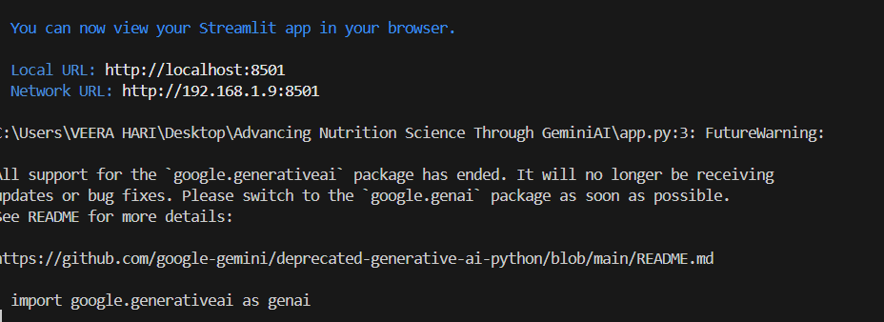

Step 3: The Streamlit webpage opens as shown in the figure given below. This is an automated webpage. No secondary HTML codes required to build this webpage. Python code itself consists the webpage building code.
Scenario 1: Dynamic Nutritional Insights Understanding the nutritional content of food is essential for making healthy choices. NutriAssist AI provides users with dynamic nutritional insights about their meals and snacks. By inputting food items or scanning barcodes, users can instantly receive detailed information about macronutrients (protein, fat, carbohydrates), micronutrients (vitamins, minerals), and calorie content. This empowers users to make conscious decisions about their food intake and track their progress toward their nutritional goals.

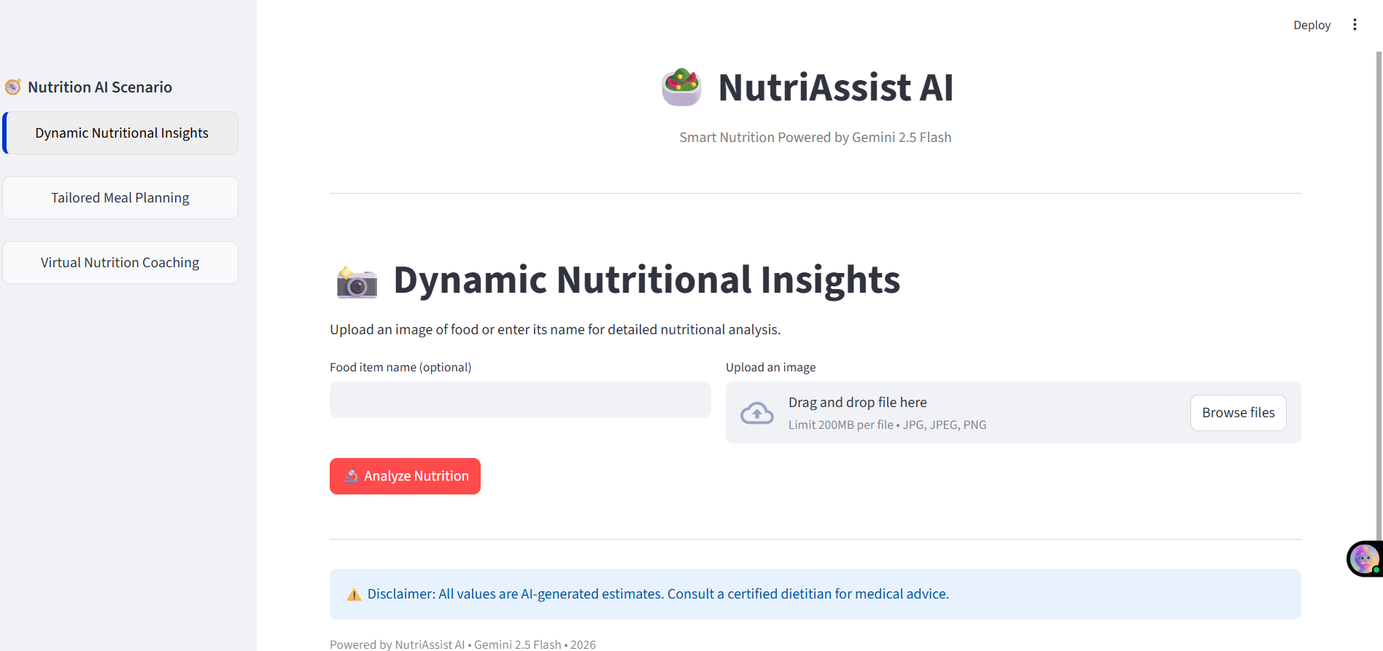

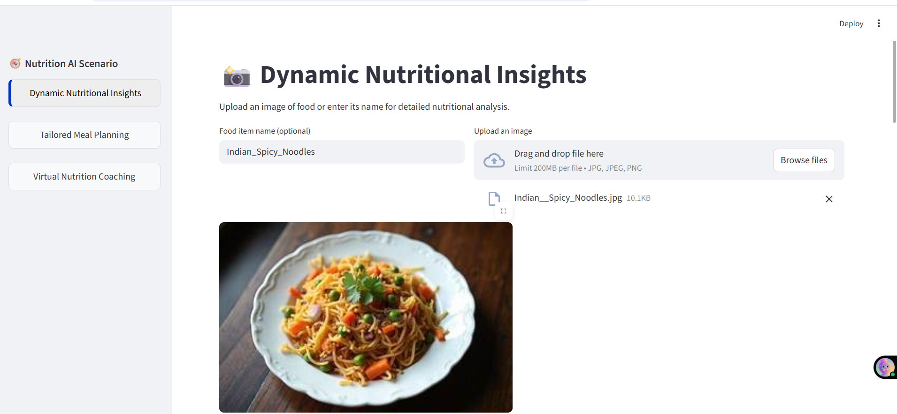

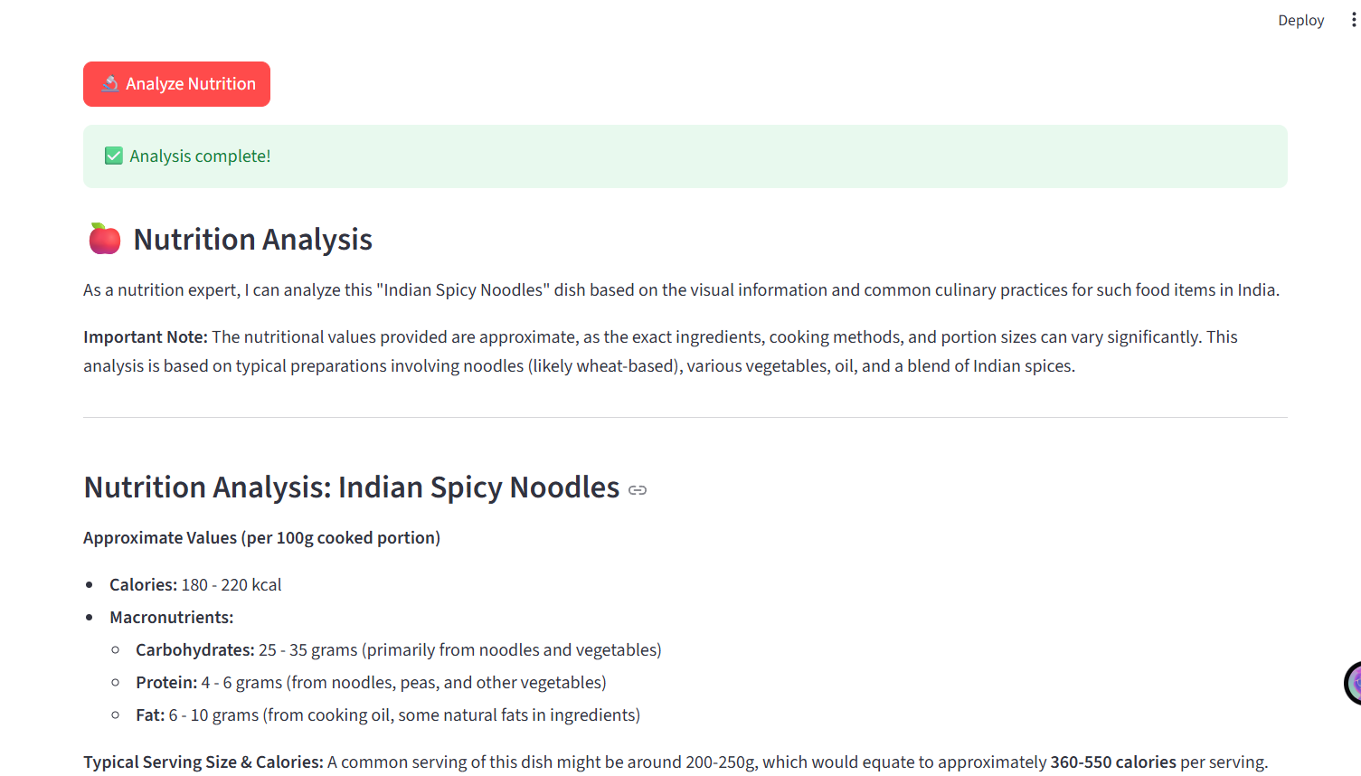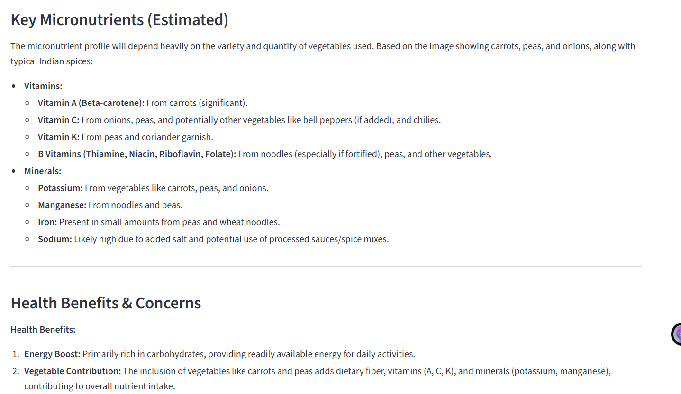
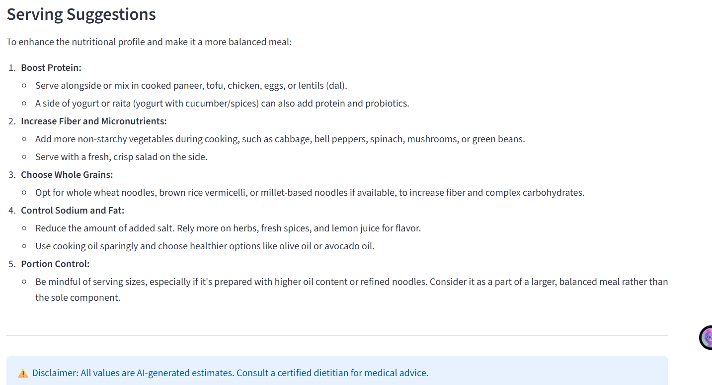
Step 4:
Scenario 2: Tailored Meal Planning Many individuals struggle with creating healthy and satisfying meal plans that align with their specific needs and preferences. NutriAssist AI addresses this challenge by generating personalized meal plans based on user input. Users can provide information about their dietary restrictions, allergies, health conditions, activity levels, and taste preferences. The AI then crafts a week-long meal plan with recipes and grocery lists, ensuring nutritional balance, variety, and enjoyment.

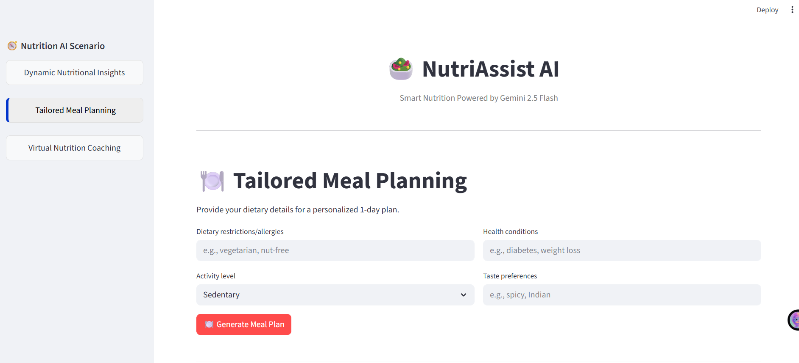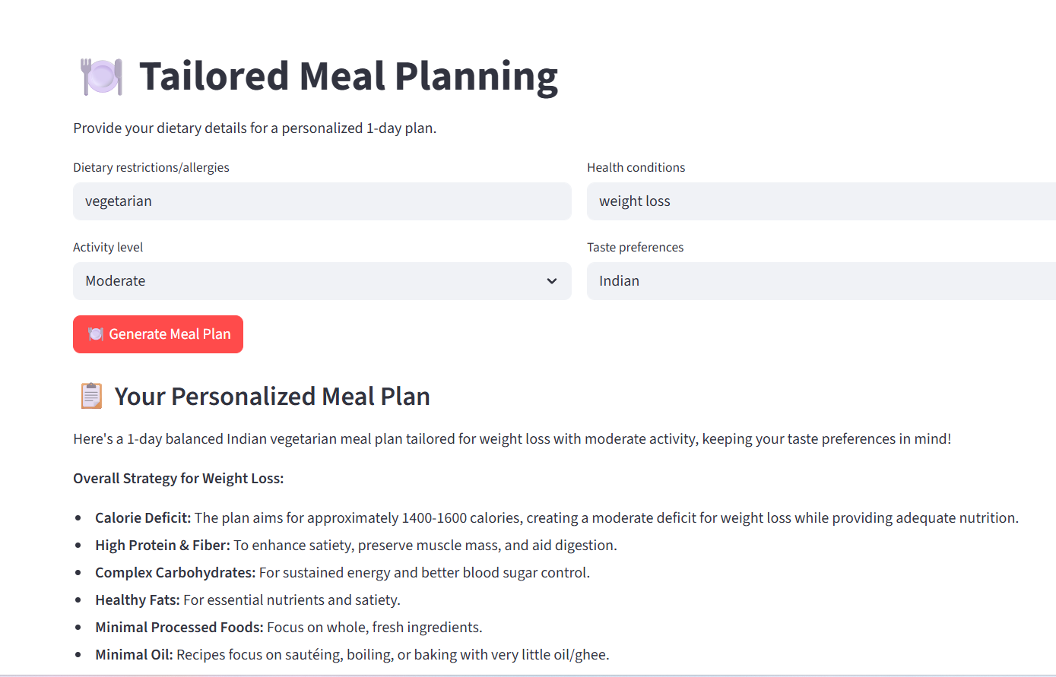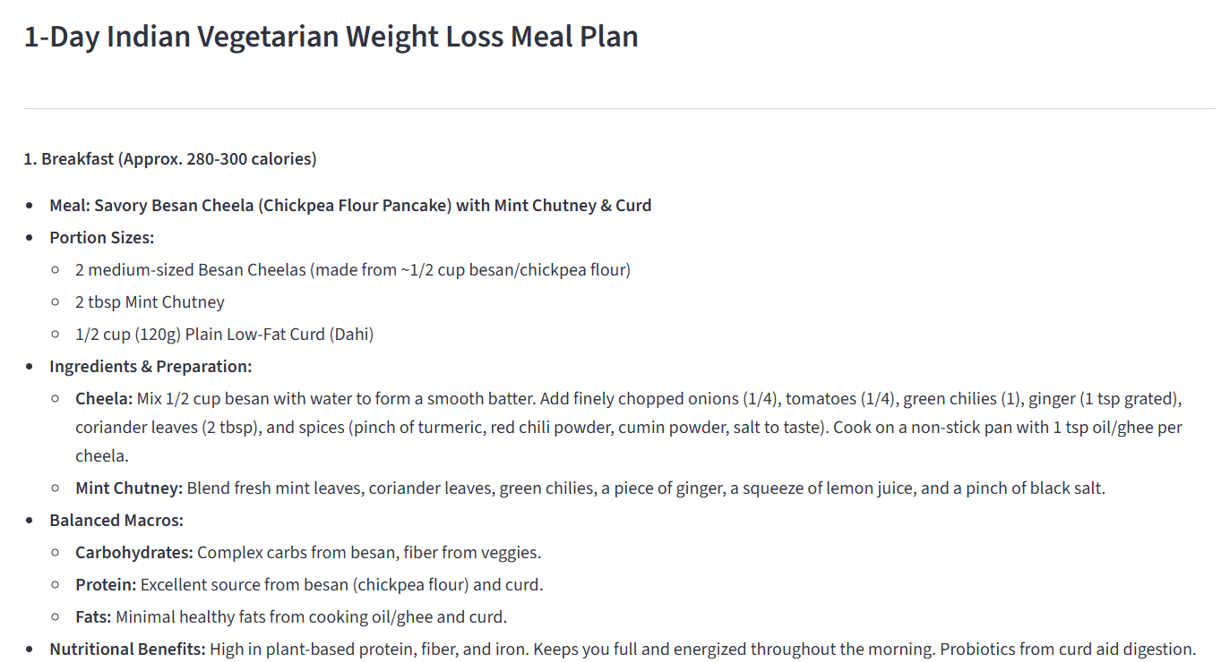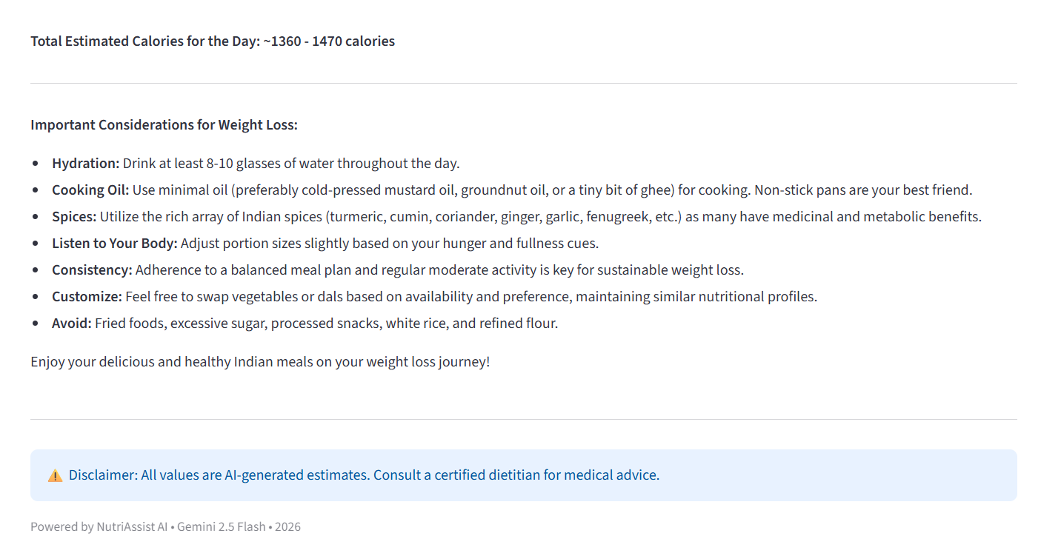
Step 5:
Scenario 3: Virtual Nutrition Coaching Receiving personalized guidance from a nutrition expert can be costly and time-consuming. NutriAssist AI democratizes access to nutritional expertise by offering virtual nutrition coaching. The AI acts as a virtual coach, providing users with personalized advice, answering questions, and offering support throughout their wellness journey. This interactive coaching experience helps users stay motivated, make sustainable lifestyle changes, and achieve long-term health improvements.
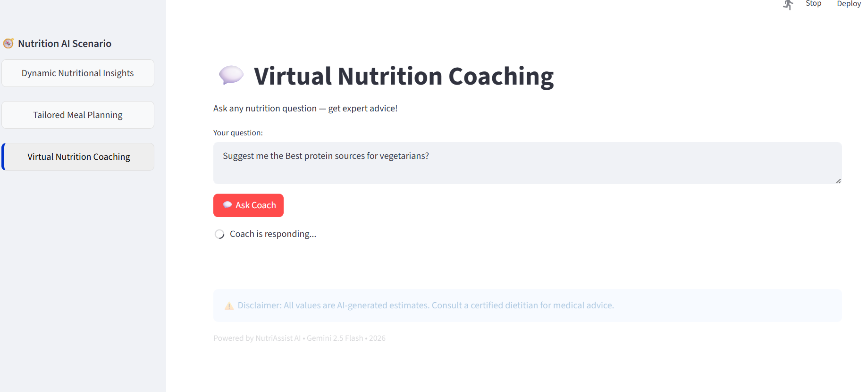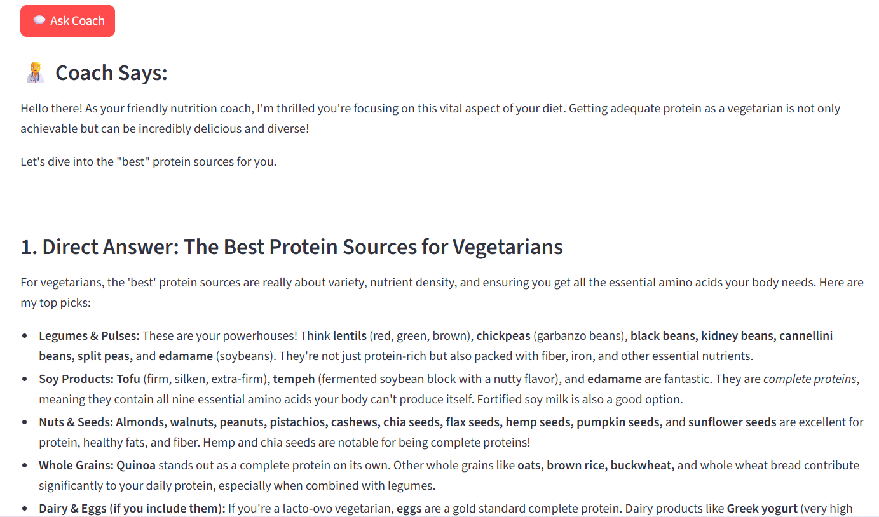
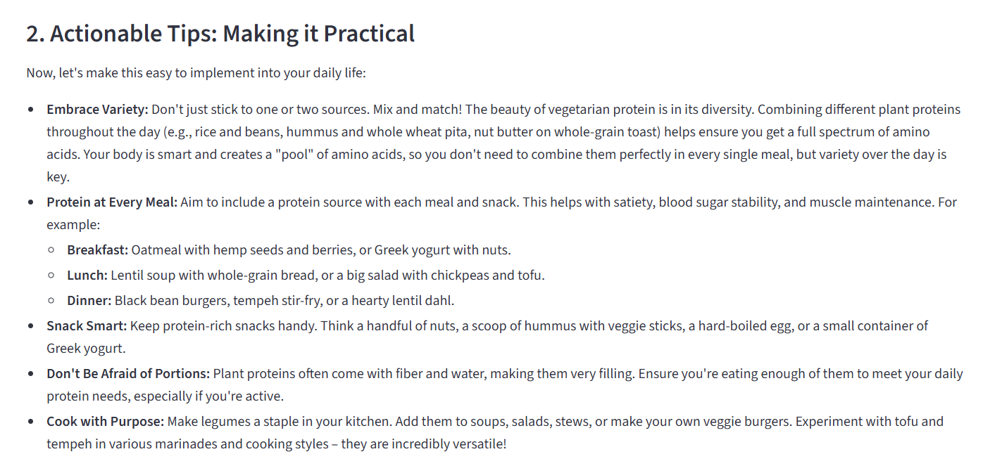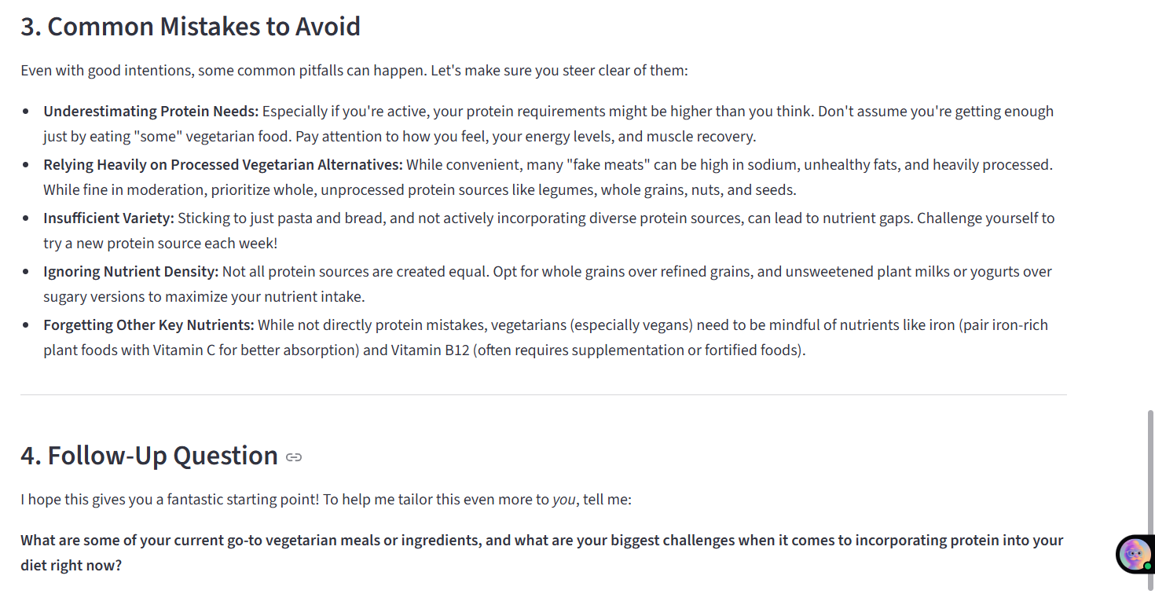

7. ADVANTAGES AND DISADVANTAGES
Advantages
- Provides real-time nutrition insights
- Generates personalized meal plans
- Offers AI-powered virtual nutrition coaching
- User-friendly and interactive interface
- No dataset required for training
- Fast and efficient response generation
- Supports both text and image input
- Helps users make healthier lifestyle decisions

Disadvantages
- Requires continuous internet connection
- Depends on third-party AI API services
- Accuracy depends on clarity of user input
- Cannot replace professional medical consultation
- Limited offline functionality

8. CONCLUSION
The Advancing Nutrition Science through GeminiAI(NutriAssist AI) project successfully demonstrates the application of generative AI in the field of nutrition and healthcare. The system provides intelligent nutritional insights, personalized meal planning, and virtual coaching through an easy-to-use web interface.
By leveraging Gemini AI, the application helps users understand food composition, make informed dietary decisions, and adopt healthier lifestyle habits. The project highlights how AI can make personalized nutrition guidance accessible, affordable, and efficient for everyone.

9. FUTURE SCOPE
The project can be further enhanced with the following improvements:
- Barcode-based food scanning.
- Mobile application development (Android/iOS)
- Multi-language support for wider accessibility
- Diet tracking and progress monitoring dashboard
- Integration with wearable fitness and health devices
- AI-based calorie tracking system
- Voice-based interaction with nutrition coach
- Personalized diet recommendations based on medical history
These future enhancements will further improve usability, accuracy, and real-world applicability.

10. APPENDIX
10.1. Source Code
The project is implemented using Python and Streamlit and integrates Google Gemini AI for nutrition analysis, meal planning, and coaching.
CODE
import os
import streamlit as st
import google.generativeai as genai
from dotenv import load_dotenv
from PIL import Image

# ------------------ CONFIG ------------------
st.set_page_config(
page_title="NutriAssist AI",
layout="wide"
)

# Main Heading
st.markdown("<h1 style='text-align: center;'>🥗 NutriAssist AI</h1>", unsafe_allow_html=True)
st.markdown("<p style='text-align: center; color: gray;'>Smart Nutrition Powered by Gemini 2.5 Flash</p>", unsafe_allow_html=True)
st.markdown("---")

# Load API key
load_dotenv()
genai.configure(api_key=os.getenv("GOOGLE_API_KEY"))

# Gemini Model (Vision + Text Supported)
model = genai.GenerativeModel("models/gemini-2.5-flash")

# ------------------ CUSTOM SIDEBAR STYLE ------------------
st.markdown("""
<style>
section[data-testid="stSidebar"] .stButton > button {
width: 100%;
text-align: left;
padding: 10px 14px;
margin-bottom: 8px;
border-radius: 8px;
border: 1px solid #e0e0e0;
background-color: #f8f9fa;
font-weight: 500;
transition: all 0.2s ease-in-out;
}

section[data-testid="stSidebar"] .stButton > button:hover {
background-color: #1a8cff;
color: white;
}

section[data-testid="stSidebar"] .stButton > button[kind="primary"] {
border-left: 5px solid #0033cc;
background-color: #eeeeee;
color: black;
font-weight: 600;
}
</style>
""", unsafe_allow_html=True)

# ------------------ SIDEBAR NAVIGATION ------------------
if "page" not in st.session_state:
st.session_state.page = "Dynamic Nutritional Insights"

st.sidebar.markdown("### 🧭 Nutrition AI Scenario")

pages = [
"Dynamic Nutritional Insights",
"Tailored Meal Planning",
"Virtual Nutrition Coaching"
]

for page in pages:
def set_page(p=page):
st.session_state.page = p

st.sidebar.button(
page,
key=f"btn_{page}",
use_container_width=True,
type="primary" if st.session_state.page == page else "secondary",
on_click=set_page
)

option = st.session_state.page

# ================== PAGE 1 ==================
if option == "Dynamic Nutritional Insights":
st.title("📸 Dynamic Nutritional Insights")
st.write("Upload an image of food or enter its name for detailed nutritional analysis.")

col1, col2 = st.columns([2, 3])
with col1:
food_name = st.text_input("Food item name (optional)")
with col2:
uploaded_image = st.file_uploader("Upload an image", type=["jpg", "jpeg", "png"])

image = None
if uploaded_image:
image = Image.open(uploaded_image)
st.image(image, caption="Uploaded Image", width=500)

if st.button("🔬 Analyze Nutrition", type="primary"):
if not image and not food_name:
st.warning("Please provide food name or image!")
else:
with st.spinner("Analyzing nutrition using Gemini AI..."):
prompt = f"""
You are a nutrition expert.

Analyze the food based on:
Food name: {food_name if food_name else "Image provided"}

Provide:
• Calories (per 100g or serving)
• Macronutrients (carbs, protein, fat in grams)
• Key micronutrients (vitamins & minerals)
• Health benefits & concerns
• Serving suggestions

Mention clearly values are approximate.
"""

try:
if image:
response = model.generate_content([prompt, image])
else:
response = model.generate_content(prompt)

st.success("✅ Analysis complete!")
st.subheader("🍎 Nutrition Analysis")
st.markdown(response.text)

except Exception as e:
st.error(f"Error: {str(e)}")

# ================== PAGE 2 ==================
elif option == "Tailored Meal Planning":
st.title("🍽️ Tailored Meal Planning")
st.write("Provide your dietary details for a personalized 1-day plan.")

col1, col2 = st.columns(2)
with col1:
diet = st.text_input("Dietary restrictions/allergies", placeholder="e.g., vegetarian, nut-free")
activity = st.selectbox("Activity level", ["Sedentary", "Moderate", "Active", "Athlete"])
with col2:
condition = st.text_input("Health conditions", placeholder="e.g., diabetes, weight loss")
taste = st.text_input("Taste preferences", placeholder="e.g., spicy, Indian")

if st.button("🍽️ Generate Meal Plan", type="primary"):
with st.spinner("Creating your meal plan..."):
prompt = f"""
Create a 1-day balanced meal plan (3 meals + 2 snacks) for:

Diet: {diet or 'None'}
Health condition: {condition or 'General health'}
Activity level: {activity}
Taste preferences: {taste or 'Balanced'}

Include:
• Portion sizes
• Calories per meal
• Balanced macros
• Easy Indian-friendly ingredients
• Nutritional benefits per meal
"""

try:
response = model.generate_content(prompt)
st.subheader("📋 Your Personalized Meal Plan")
st.markdown(response.text)
except Exception as e:
st.error(f"Error: {str(e)}")

# ================== PAGE 3 ==================
elif option == "Virtual Nutrition Coaching":
st.title("💬 Virtual Nutrition Coaching")
st.write("Ask any nutrition question — get expert advice!")

question = st.text_area(
"Your question:",
height=100,
placeholder="e.g., Best protein sources for vegetarians?"
)

if st.button("💬 Ask Coach", type="primary"):
if question:
with st.spinner("Coach is responding..."):
prompt = f"""
You are a friendly expert nutrition coach.

Answer clearly and practically:

Question: {question}

Structure:
1. Direct answer
2. Actionable tips
3. Common mistakes
4. Follow-up question
"""

try:
response = model.generate_content(prompt)
st.markdown("### 🧑‍⚕️ Coach Says:")
st.markdown(response.text)
except Exception as e:
st.error(f"Error: {str(e)}")

# ------------------ FOOTER ------------------
st.markdown("---")
st.info(
"⚠️ Disclaimer: All values are AI-generated estimates. "
"Consult a certified dietitian for medical advice."
)
st.caption("Powered by NutriAssist AI • Gemini 2.5 Flash • 2026")

10.2. Github & Project Demo Link
Github :-
Demo Video :-

